The objective is to explain the business concept, how customers use the application, how stores manage orders, how delivery partners work, how location-based delivery operates, what technology is required

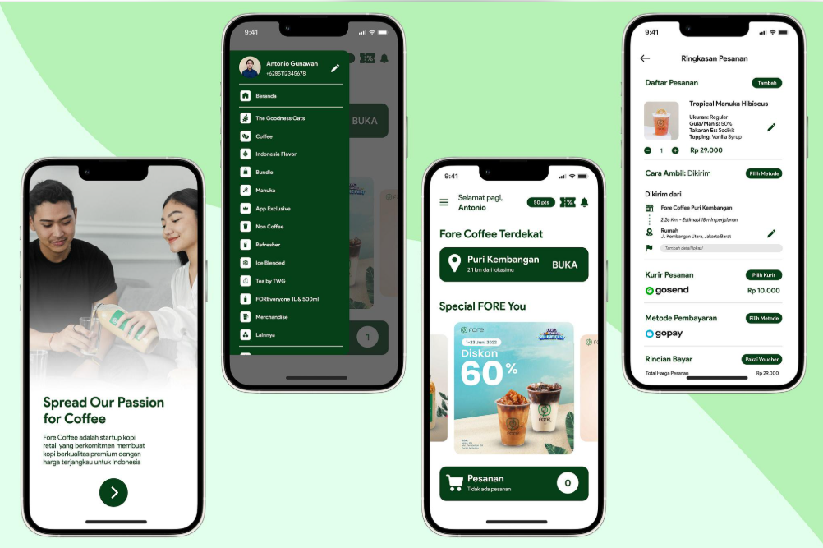

1. Project introduction – What are we building?
An e-commerce website where customers can browse products, add products to their shopping cart, place orders and make payments.
The proposed application will allow customers to order products from their nearby store and receive them at their doorstep within a short delivery window, depending on the location, inventory availability and delivery capacity.
The application will provide an experience similar to Blinkit, Zepto and Instamart, but it will be customized exclusively around own products, branding, business operations and delivery model.

2. Overall application ecosystem
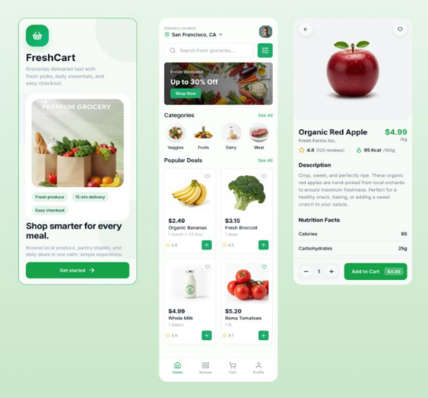
The project will consist of four interconnected applications.
Application 1 – Customer Mobile App
Customers can select their location, browse products, check availability, place orders, make payments and track deliveries.

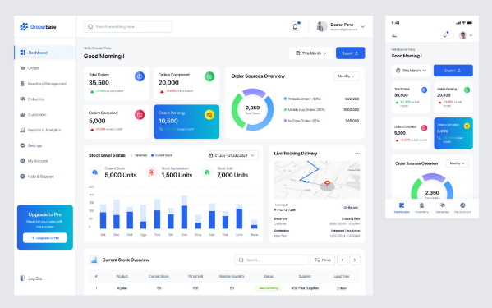
Application 2 – Store Management App
Store employees can receive orders, check product availability, prepare packages, update stock and mark orders ready for pickup.

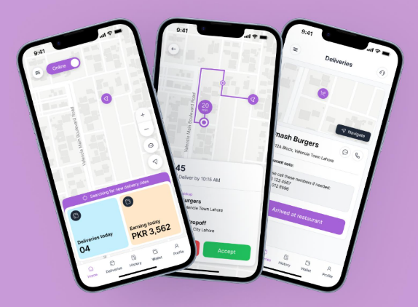
Application 3 – Delivery Partner App
Delivery partners can receive assigned orders, accept deliveries, navigate to stores and customers, and update delivery status.

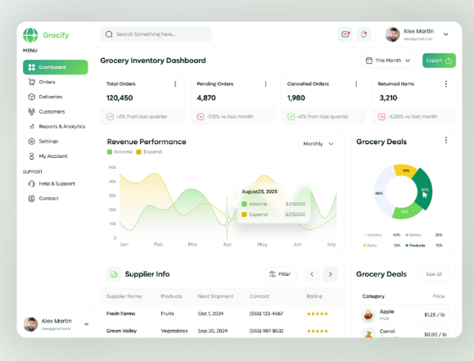
Application 4 – Super Admin Dashboard
Business owners can manage customers, stores, products, inventory, orders, delivery partners, delivery zones, payments and reports.

All four applications will communicate with a centralized backend and database, ensuring that every order, stock update and delivery status is synchronized.

3. Customer application – Complete functionality
The customer application is the primary interface of the platform.

The objective is to make the shopping experience simple, fast and convenient.
When customers open the application, they will see branding.
Features:
- Company Logo
- Premium brand colors.
- Welcome message.
- Get Started button.
- Login and registration.
- Mobile number authentication using OTP.
Customers can register using their mobile number and verify their identity through OTP.

Location selection
This is one of the most important features.
Unlike a traditional e-commerce website, the application needs to understand where the customer wants the order delivered.
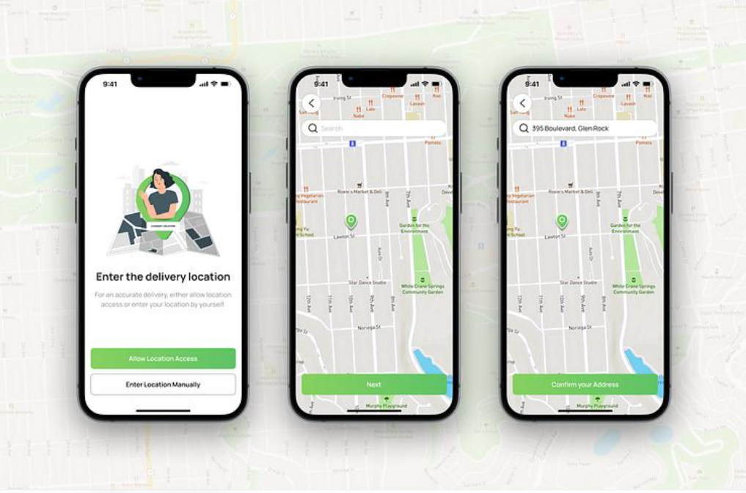
The application will provide:
- Current location detection.
- GPS-based location selection.
- Manual address entry.
- Google Maps location selection.
- Saved delivery addresses.
- Pin code and serviceability validation.
Example:
Suppose company operates a delivery store in Area A.
A customer from Area A opens the application. The system checks the customer's location and verifies whether delivery is supported.
If the location is serviceable, the customer can continue shopping.
If it is outside the service area, the application displays a message such as:
"Sorry! Delivery is not available in your location yet. We are coming soon."
This prevents customers from placing orders that cannot be delivered.

Home screen
The home screen will be customized according to the brand.
It will contain:
- Customer delivery location.
- Search bar.
- Promotional banners.
- Product categories.
- Popular products.
- Best-selling products.
- New arrivals.
- Special offers.
- Recommended products.
- Cart shortcut.
- Order history.
- Customer profile.
The categories and products will be controlled through the admin dashboard.

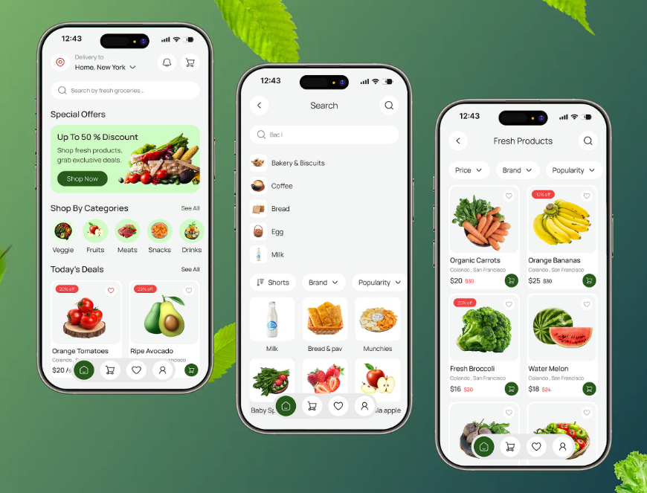

Product listing and product details
Customers can browse available products and view:
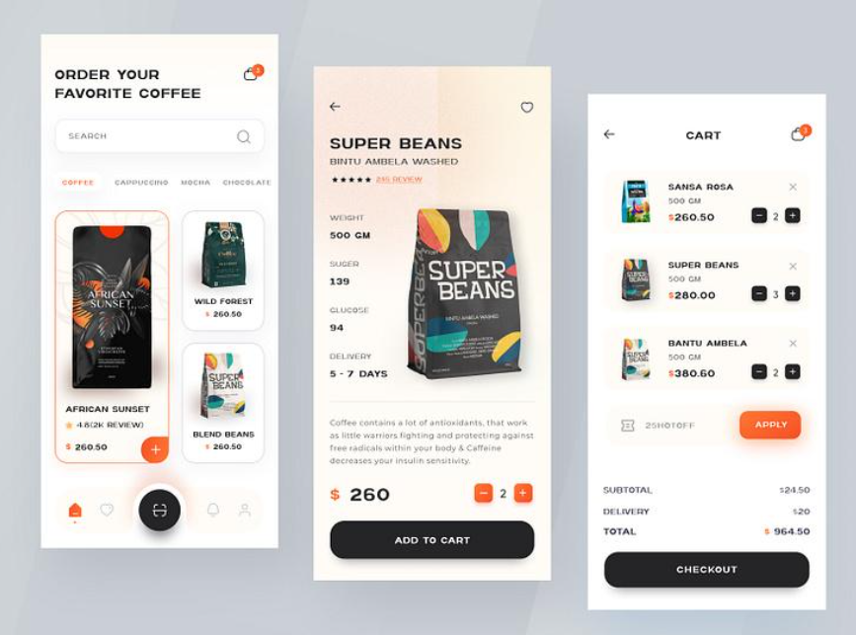
- Product images.
- Product name.
- Product description.
- Price.
- Discounted price.
- Available variants.
- Product quantity.
- Stock availability.
- Add-to-cart button.

The actual product details and pricing will come from the existing product catalogue. An important feature is that customers will see only products available for their assigned delivery store.
Shopping cart
After selecting products, customers can add them to their cart.
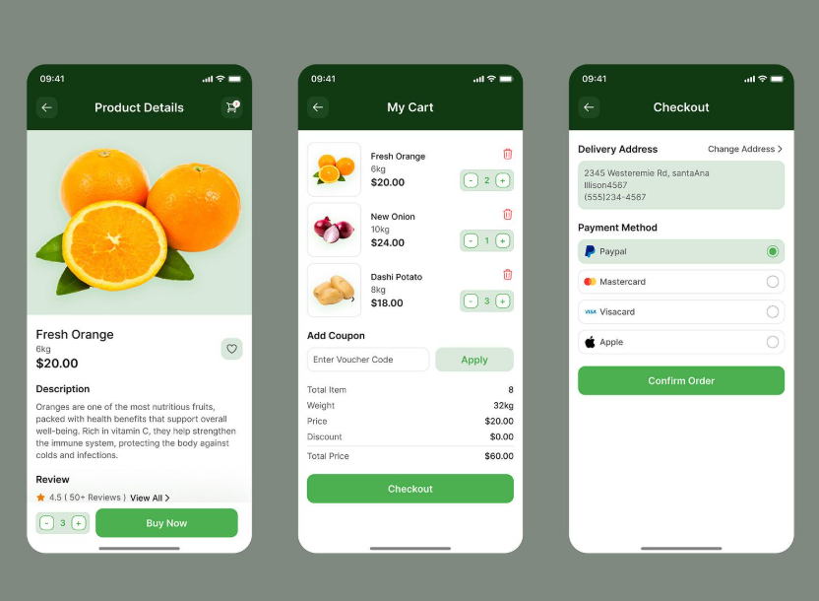
The cart will display:
- Product name.
- Product variant.
- Quantity.
- Individual price.
- Subtotal.
- Delivery charges.
- Applicable discounts.
- Taxes.
- Final payable amount.

Customers can increase or decrease product quantities and remove products.
The application will validate inventory again before order confirmation.

Checkout and payment
At checkout, customers can:
- Select a saved delivery address.
- Add a new address.
- Enter delivery instructions.
- Select payment method.
- Apply promotional coupons.
- Review the final amount.
- Confirm their order.
Payment methods can include:
- UPI.
- Credit and debit cards.
- Cash on Delivery, if enabled by the business.
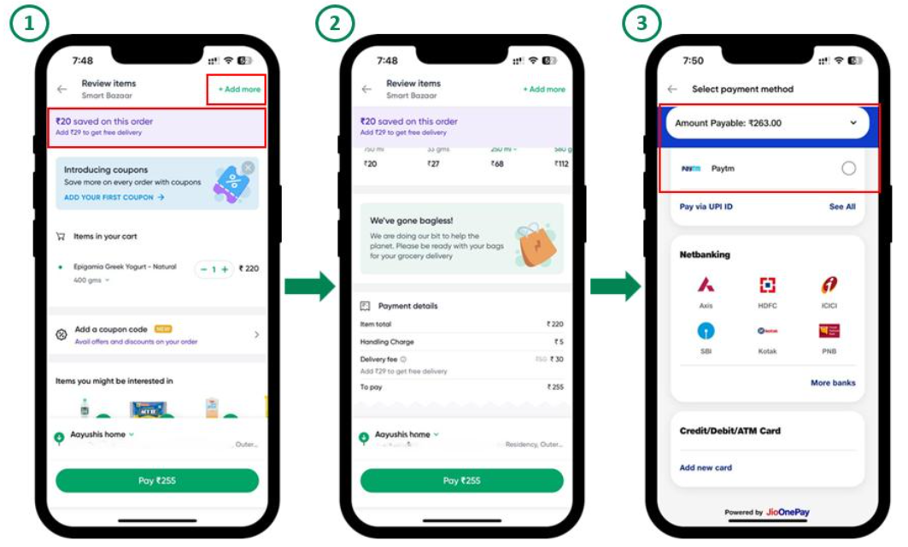
We can reuse the Razor pay integration from your website, subject to validating its current backend payment flow and configuring the production credentials.

Order confirmation
Once payment and order creation are successful, customers receive an order confirmation.
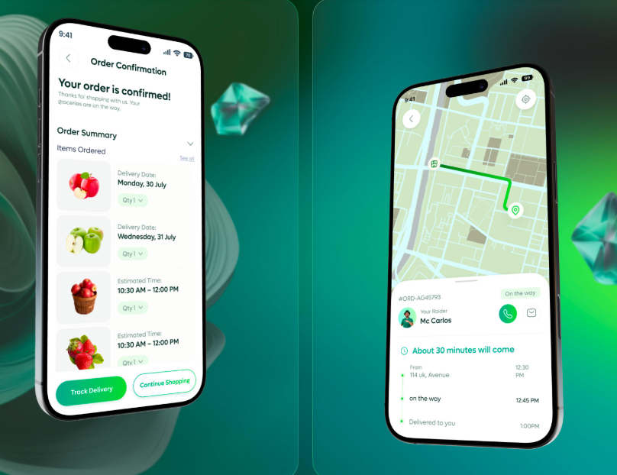
The confirmation screen will display:
- Order ID.
- Order summary.
- Payment status.
- Assigned store.
- Expected delivery window.
- Track Order button.

Customers will also receive notifications about important order updates.
Live order tracking
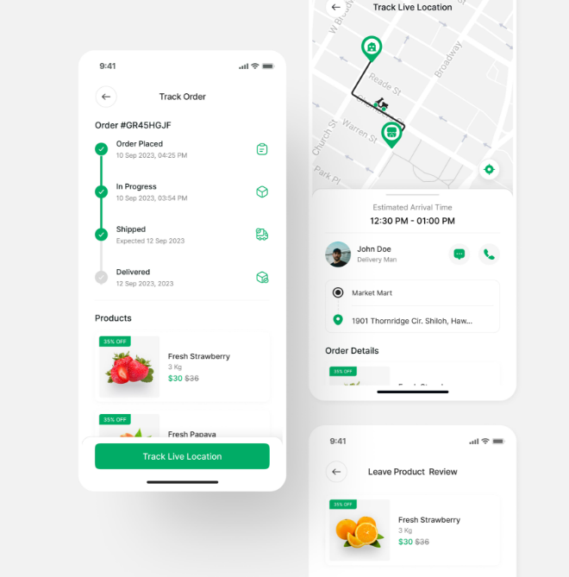
Customers can track the progress of their orders.
The order lifecycle will be:
- Order placed.
- Order confirmed.
- Store preparing order.
- Order packed.
- Delivery partner assigned.
- Rider picked up order.
- Rider on the way.
- Order delivered.
The customer can view the delivery partner's location on a map once the rider starts sharing their location.
The application can also provide:
- Estimated arrival time.
- Delivery partner details.
- Contact delivery partner.
- Order status notifications.
- Delivery OTP verification.
Important: Live tracking will use periodic GPS updates and WebSocket or another real-time communication mechanism. Delivery ETA will be an estimate based on operational conditions, not an unconditional delivery guarantee.

Store management application – Complete functionality
The store management application is used by the employees responsible for fulfilling customer orders.
Whenever a customer places an order, the assigned store receives an order notification.
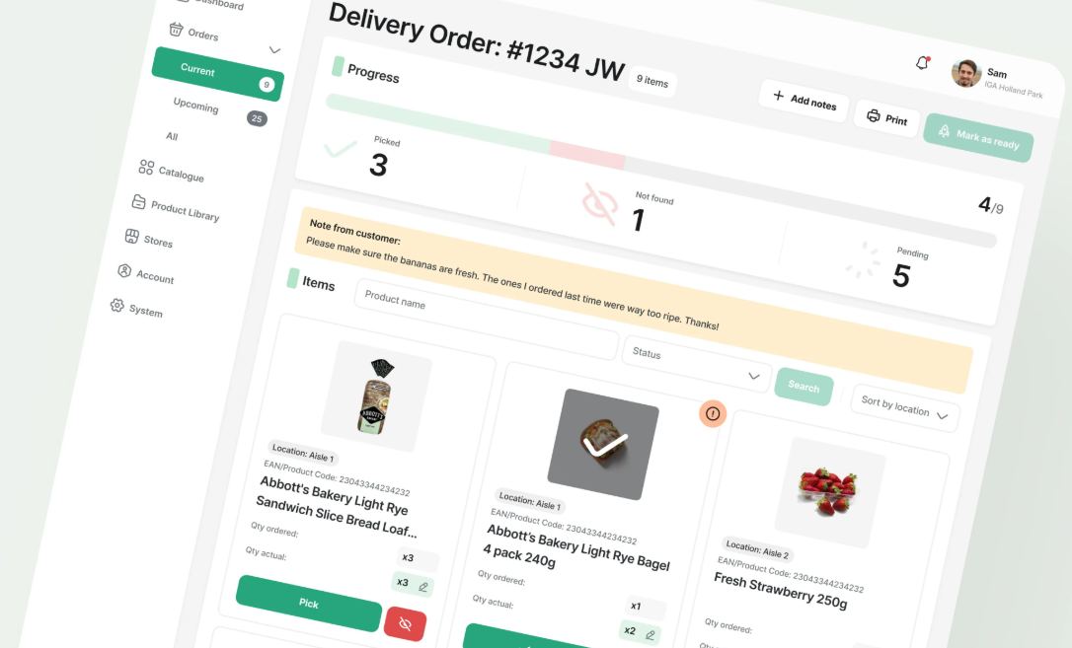

4.1 Store login
Each store employee will have an individual login.
The system can support different roles:
- Store manager.
- Store supervisor.
- Store employee.
- Inventory manager.
Each role will have access only to the functions permitted by the administrator.
4.2 Incoming orders
When a customer places an order, the store dashboard displays:
- Order ID.
- Customer name.
- Customer address.
- Ordered products.
- Product quantities.
- Payment status.
- Order time.
- Delivery instructions.
The store employee can accept an order, subject to business rules.
4.3 Order preparation
After accepting the order, the store employee starts preparing it.
The workflow:
- Receive order.
- Verify product availability.
- Pick products from inventory.
- Check product variants and quantities.
- Pack products.
- Mark the order as Ready for Pickup.
The system will automatically update the customer application when the order status changes.

4.4 Inventory management
The store dashboard will maintain stock separately for each location.
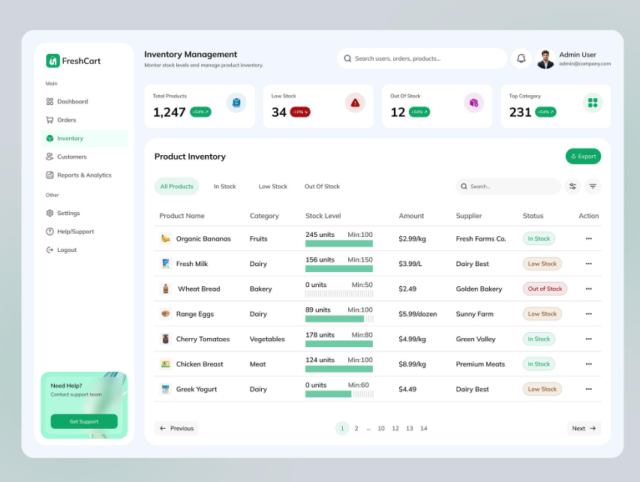
Whenever an order is confirmed, the corresponding stock is reserved.
After successful fulfilment, the stock deduction is finalized.
The system will also support:
- Add stock.
- Update stock.
- Stock adjustments.
- Low-stock alerts.
- Out-of-stock management.
- Stock movement history.
- Inventory reports.
The administrator can configure minimum stock thresholds for each product at each store.
4.5 Store performance reports
The store manager can view:
- Total orders received.
- Orders completed.
- Orders cancelled.
- Average preparation time.
- Current inventory.
- Low-stock products.
- Daily sales.
This helps the business understand how efficiently each store operates.

5. Delivery partner application
The delivery partner application connects stores with customers.
The objective is to make delivery allocation, pickup and order completion easy to manage.
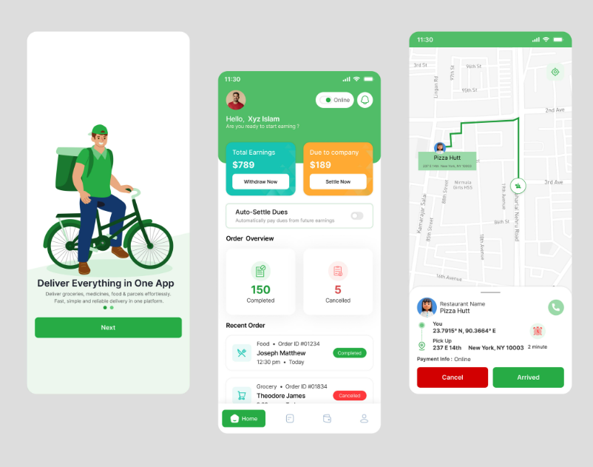

5.1 Delivery partner registration
The administrator can create delivery partner accounts.
Partner information:
- Name.
- Mobile number.
- Email.
- Profile photograph.
- Vehicle details.
- Vehicle registration number.
- Identity verification details.
- Account status.
The administrator can approve or deactivate delivery partners.
5.2 Rider availability
Delivery partners can switch their status:
- Online.
- Offline.
- Busy.
- Temporarily unavailable.
Only eligible online delivery partners should receive new delivery assignments.
5.3 Order assignment
Once the store marks an order Ready for Pickup, the system identifies an available delivery partner.
The assignment can consider:
- Rider's current location.
- Distance from the store.
- Availability.
- Existing assigned orders.
- Vehicle type.
- Expected delivery time.
Initially, the administrator can assign riders manually.
In a later version, the system can automate this process.
5.4 Pickup process
The rider receives the following information:
- Order ID.
- Store name.
- Store address.
- Pickup location.
- Customer delivery location.
- Delivery instructions.
The rider navigates to the store and confirms pickup.
5.5 Customer delivery
After pickup, the delivery partner navigates to the customer's address.
The customer can see the rider's location on the map.
When the rider reaches the customer, the delivery can be verified using an OTP.
Once verified, the order is marked Delivered.
5.6 Delivery history and earnings
The delivery partner can view:
- Completed deliveries.
- Pending deliveries.
- Cancelled deliveries.
- Daily delivery count.
- Delivery earnings.
- Weekly and monthly performance.
Earnings calculation and payout management can be configured according to the business's delivery-partner agreement.
6. Super Admin dashboard – Complete business management
The Super Admin Dashboard is the central control panel of the entire Quick Delivery. The business owner can manage all operations from one place.
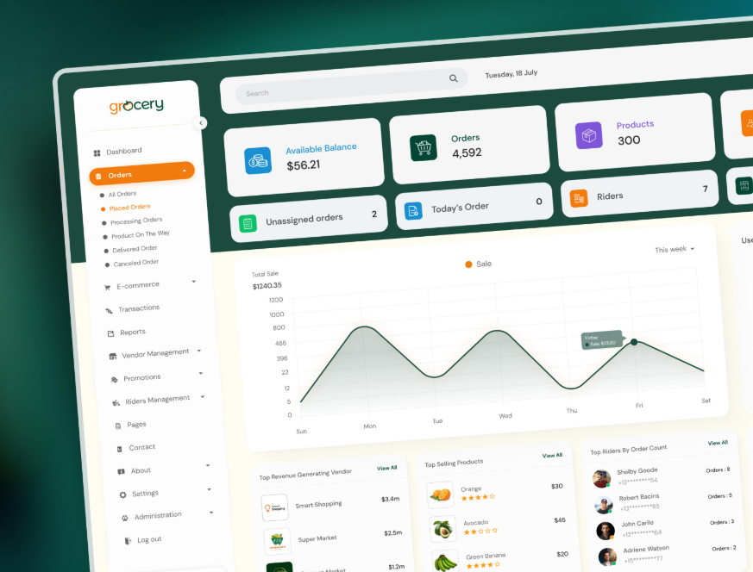
6.1 Dashboard overview
The dashboard will display business performance metrics.
Dashboard metric | Information
Total orders | All orders received
Today's orders | Orders received today
Pending orders | Orders awaiting processing
Completed orders | Successfully delivered
Cancelled orders | Cancelled orders
Total revenue | Sales revenue
Active stores | Currently operational stores
Active riders | Available delivery partners
Charts can show:
- Daily order trends.
- Weekly and monthly sales.
- Revenue by store.
- Best-selling products.
- Delivery performance.
- Order cancellation trends.
6.2 Product management
The administrator can:
- Add new products.
- Edit product information.
- Upload multiple product images.
- Configure variants.
- Set prices.
- Set discounts.
- Manage categories.
- Activate or deactivate products.
- Manage product availability.
The existing catalogue can be reused as the starting point.
6.3 Store management
The administrator can add multiple stores.
Each store will have:
- Store name.
- Store code.
- Address.
- Latitude and longitude.
- Contact information.
- Opening and closing hours.
- Operating status.
- Assigned employees.
- Serviceable delivery areas.
The platform should support adding more stores in the future without changing the core application.
6.4 Delivery zone management
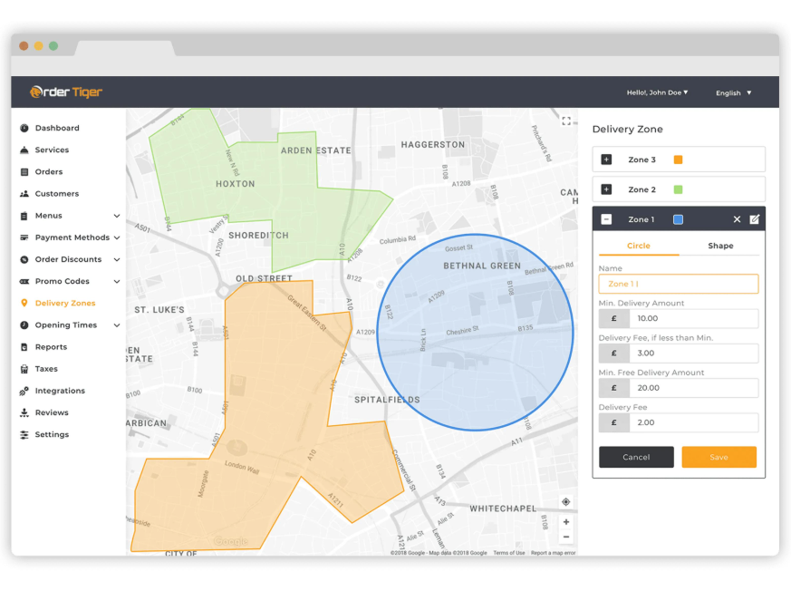
The administrator can configure the delivery areas.
For example:
Zone |  |  |  |  |  |  |  |  |  |  |  |  |  |  |  | Delivery radius |  |  |  |  |  |  |  |  |  |  |  |  |  |  |  |  |  |  |  |  |  |  |  |  |  |  |  |  | Delivery fee
Zone A |  |  |  |  |  |  |  |  |  |  |  |  |  |  |  | 2 km |  |  |  |  |  |  |  |  |  |  |  |  |  |  |  |  |  |  |  |  |  |  |  |  |  |  |  |  | Configurable
Zone B |  |  |  |  |  |  |  |  |  |  |  |  |  |  |  | 3 km |  |  |  |  |  |  |  |  |  |  |  |  |  |  |  |  |  |  |  |  |  |  |  |  |  |  |  |  | Configurable
Zone C |  |  |  |  |  |  |  |  |  |  |  |  |  |  |  | 5 km |  |  |  |  |  |  |  |  |  |  |  |  |  |  |  |  |  |  |  |  |  |  |  |  |  |  |  |  | Configurable
These are example configurations.
The actual service area can be created using either:
- Radius-based delivery.
- Pincode-based delivery.
- Custom geographical boundaries (polygons).
Custom geographical boundaries are particularly useful because delivery areas do not always follow perfect circular boundaries.
The admin can enable, disable or modify zones.
6.5 Order management
The administrator can view every order in the system.
Order filters:
- Order ID.
- Customer.
- Store.
- Date.
- Payment status.
- Delivery status.
- Delivery partner.
Admin capabilities:
- View order details.
- Monitor order progress.
- Assign delivery partners.
- Reassign riders.
- Cancel orders according to policy.
- Handle refunds.
- Review order history.
6.6 Delivery partner management
The administrator can:
- Register delivery partners.
- Approve partner accounts.
- Activate or deactivate accounts.
- Monitor online and offline status.
- View assigned orders.
- Track delivery performance.
- Manage delivery charges and payout records.
6.7 Offers and promotions
The platform can support:
- Discount coupons.
- Percentage discounts.
- Fixed-value discounts.
- First-order offers.
- Product-specific offers.
- Minimum-order-value offers.
- Promotional banners.
- Category offers.
For example, the admin can create a promotion for Signature Coffee without changing the actual product price.
6.8 Reports and analytics
The system can generate reports such as:
- Daily sales report.
- Monthly revenue report.
- Product sales report.
- Store performance report.
- Delivery performance report.
- Inventory report.
- Customer order history.
- Payment and refund report.
These reports help management make business decisions using actual operational data.

